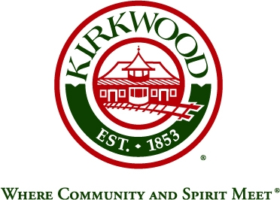

**KIRKWOOD CITY COUNCIL – VISION ZERO TASK FORCE**

**AGENDA**

**KIRKWOOD CITY HALL – MAIN LEVEL CONFERENCE ROOM**

**139 SOUTH KIRKWOOD ROAD**

**May 6th, 2019**

**5:30 P.M.**

# I. WELCOME & INTRODUCTIONS

###### II. PUBLIC COMMENTS – 3 Minute Limit Per Person

###### III. BIKE WAYFINDING

**IV. DRAFT RECOMMEDATION REPORT**

**V. DISCUSS NEXT MEETING/STEPS & DATE/TIME**

**VI. ADJOURNMENT**

The City of Kirkwood is interested in effective communication for all persons. Persons requiring an accommodation to attend and participate in the meeting should contact the Public Services Department at (314) 984-5926 at least 48 hours before the meeting. With advance notice of seven calendar days, the City of Kirkwood will provide interpreter services at public meetings for languages other than English and for the hearing impaired. Upon request, the minutes from this meeting can be made available in an alternate format, such as CD by calling (314) 984-5926. Agendas and approved minutes are available on the City’s web site at [www.kirkwoodmo.org](http://www.kirkwoodmo.org).