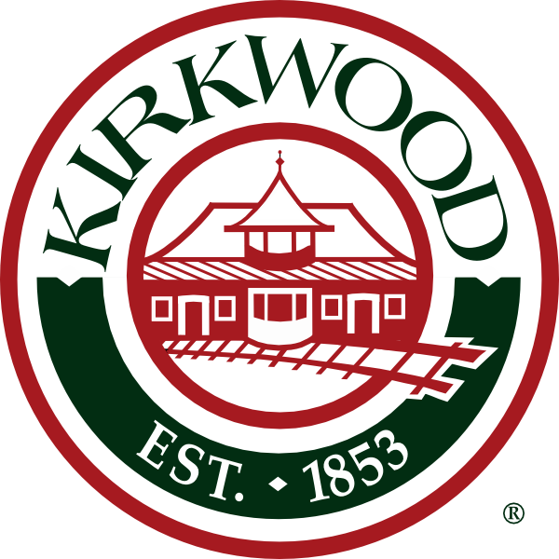
Agenda
Architectural Review Board
City of Kirkwood
Date: January 7, 2019
Place: City Council Chambers
Time: 7:00 P.M.

Approval of Minutes: December 17, 2018

Sign Review - New Business

Case No. 01-19S – 1001 S Kirkwood Rd – Mercy – Zoning B-5 – Warren Sign c/o Sue Winter, applicant. (3) new wall, (1) new monument sign. NW wall: 5’4.25” x 13’-5.75”=72.2 sq. ft. SE wall: 5’4.25”x13’5.75”=72.2 sq. ft. NE wall: 5’4.25”x13’5.75”=72.2 sq. ft. Monument: 6’x15’=90 sq. ft. Total Signage 306.6 sq. ft.

Residential Review - New Business

Case No. 01-19R – 9 Douglas Ln. – Zoning R-3 – Ken Burns, applicant. Second story addition.

Case No. 02-19R – 6 Windsor Ln. Zoning R-1 – Jeff Day & Assoc. c/o John Wimmer, applicant. Addition to existing home

Case No. 03-19R – 18 Homewood Dr. – Zoning R-3 – Villacis Group Architects, applicant. Addition at rear of house.

Case No. 04-19R – 208 W Rose Hill Ave – Zoning R-4 – John S. Odom, applicant. New SFR

Case No. 05-19R – 1515 Marshall Rd– Zoning R-3 – Gene Bentrup, applicant. Remodel and addition at rear of house.

Case No. 06-19R – 300 Couch Ave – Zoning R-4 – Michael E. Blaes, applicant. New SFR

Case No. 07-19R – 617 McKinley Ave – Zoning R-4 – DDHI, LLC – Dave Dawson, applicant. New addition and interior renovations

Case No. 08-19R – 340 Ballas Rd – Zoning R-1- Patrick Croghan, applicant. Elevator addition and interior renovations

Case No. 09-19R – 215 E Woodbine Ave – Zoning R-4 – NJL Custom Homes, applicant. New SFR

Commercial Review – New Business

Re-submittal of previously approved - Amendment

C: Bill Bensing, Director of Public Services,
Laurie Asche, City Clerk
Fredrick Doss, Deputy City Clerk
Tim Griffin, Mayor
Kara Wurtz, Liaison
Donna Poe, SBD
Elizabeth von Behren, Public Information Officer
Jonathan Raiche, City Planner
Amy Lowry, Landmarks Liaison

The city of Kirkwood is interested in effective communication for all persons. Persons requiring an accommodation to attend and participate in the meeting should contact the building commissioner’s office at 314-822-5816 at least 48 hours before the meeting. With advance notice of seven calendar days, the city of Kirkwood will provide interpreter services at public meetings for languages other than English and for the hearing impaired. Upon request, the minutes from this meeting can be made available in an alternate format, such as cd by calling 314-822-5816.

