**Greentree Festival Committee**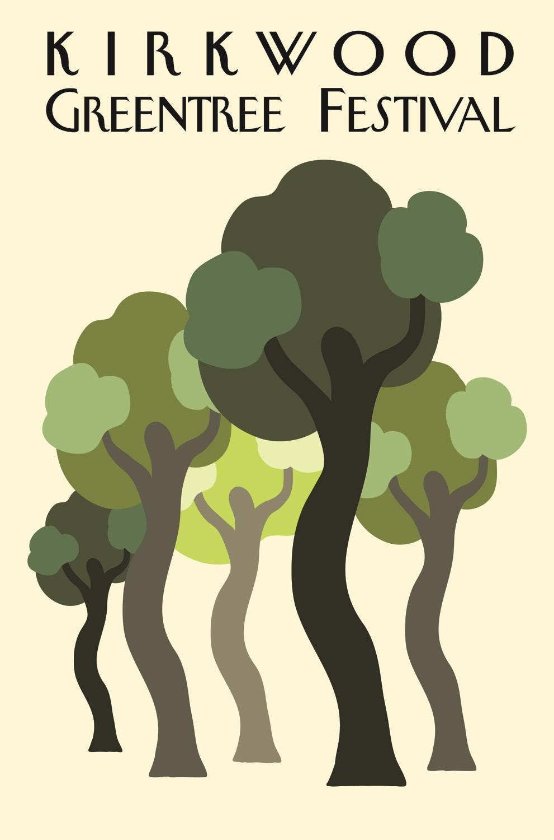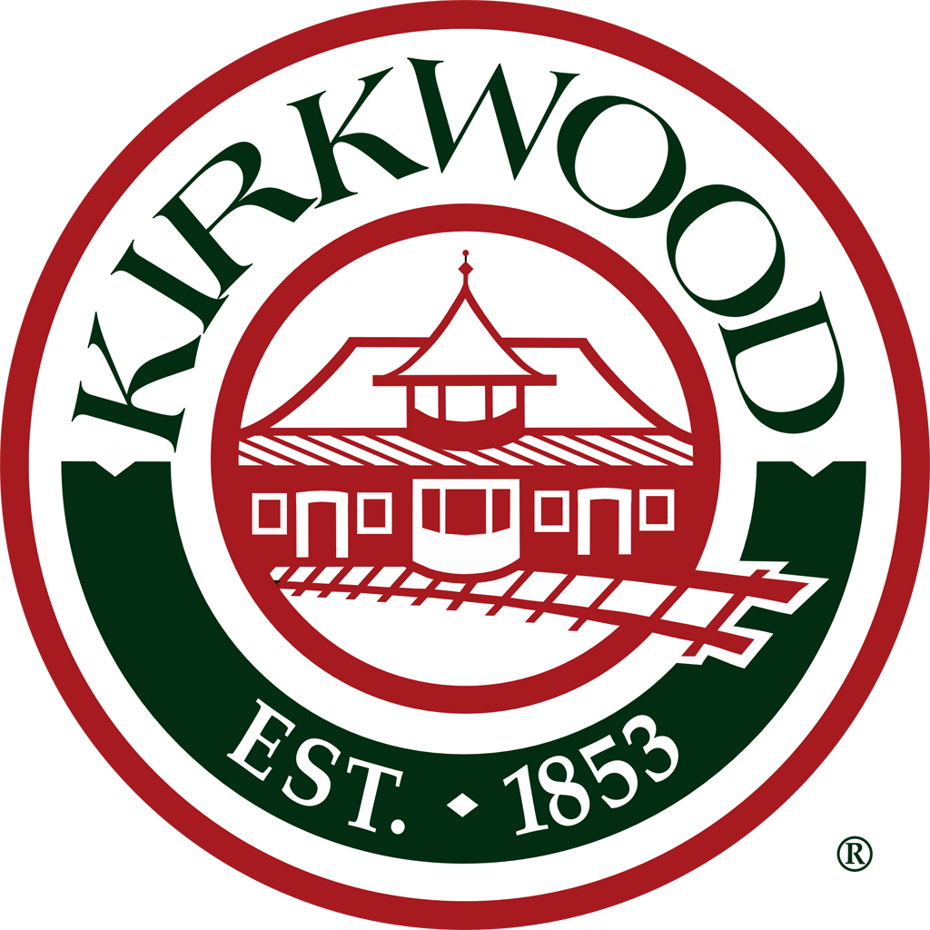

**Minutes**

**February 23, 2022 at 7:00 p.m.**

**Via Zoom**

**Kirkwood, MO 63122**

Meeting of the Greentree Festival Committee: In attendance: Mark Adams, Dan Andert, Victoria Bader, Gary Baldridge, Matt Barthelmass, Katie Burckhalter, Peggy Childress, Cindy Coombs, Gerry DeWulf, Freddy Doss, Ryan Geringer, Liz Gibbons, Kim Hedgpeth, Kyle Henke, Kate Henson, Pat Jones, Ginny Kramer, Mary Loida, Linda Ross, Debbie Stream, Joe Walsh, and two members identified in Zoom by phone numbers (xxx)xxx-0380, and (xxx)xxx-3566. Meeting was called to order by Linda Ross at 7:06 p.m.

1. **APPROVAL OF JANUARY 26, 2022 MEETING MINUTES –** approved unanimously
2. **COMMITTEE ASSIGNMENTS/REPORTS**
   1. Party in the Park – Pat – all systems go
   2. Parade – Peggy – Waiting to hear what the theme is.
   3. Entertainment – Ryan – Have some bands booked, still talking to a few new bands and hope to sign them up; currently have only 3 performance slots open.
   4. Transportation – Victoria – Made progress contacting key people.
   5. Arts & Crafts – Debbie – Excited to have only have 40 spots left, as this is really good for this stage. 111 have signed up to do booths, some of these have signed up for 2 booths, some for 3; has 5 more she’s waiting to hear from; cost is $135 a booth, up $10 from past fee.
   6. Food, Game & Info – Kate – nothing to report yet
   7. Kids Day – Laura – Kyle spoke on Laura’s behalf and said he believes Laura has some things booked already.
   8. Service Groups – Kirk – not in attendance
   9. Fundraising – Joe – Nothing to report other than to say most/all of the past sponsors will be coming back.
   10. Folk Life – Cindy – will have report next month
   11. Logistics – Matt – nothing to report yet
   12. Parade – Gerry – too early for report; nothing yet
   13. Rotary Ramble – Mark Adams – will start having Ramble committee meetings in March.
   14. Police – Dan Ander – nothing to report yet
   15. Photography – Katie/Bill – Bill said we just need to be sure don’t miss anything new/novel this year.
   16. Communications – Freddy – nothing to report yet
   17. City Council Liason – Liz – Public hearing on budget was last week and vote will be held on March 3; there will be no increase in budget for Greentree.
3. **OLD BUSINESS**
   1. Festival Theme and Tag Line – Cartoons – An initial silent ballot was held in which everyone texted their pick to Mary, resulting in a “top 4” (shown below); Freddy then set up an online silent ballot vote and the winner was Greentree Cartoon Caravan.
      1. Toon in to Greentree
      2. Toon in, Kirkwood
      3. Toon in to Kirkwood Greentree
      4. Greentree Cartoon Caravan

b. Greentree Master Timeline Link – Kyle said the document is ready for committee members to add to it, so members are encouraged to add relevant actions and information items as they arise.

c. Other Matters – Kyle reached out to graphic artist at Meramec to see if students there might be able to come up with a new graphic for Greentree; Kyle received permission to continue using the dancing trees logo if we want to use it again.

1. **NEW BUSINESS**
   1. Selection of Grand Marshall – Kyle said he contacted the mayor for input on who should be grand marshal. Mayor Tim suggested Jeremy Maclin be considered. A vote was taken and committee members expressed unanimous support for Jeremy; next step is to reach out and see if Jeremy is available.
   2. Choice of Color for T-Shirt – Freddy did another online vote and lime green was the winner.
2. **COMMITTEE MEMBER COMMENTS** - none
3. **ADJOURMENT** – Pat made a motion to adjourn, Gerry seconded, and the meeting was adjourned at 7:59pm

**Next Meeting: March 30, 2022**